Design Task
Description: The weather station sends the weather data that has been collected from the instruments in the collection period to the weather information system. The data sent are the maximum, minimum, and average ground and air temperatures; the maximum, minimum, and average air pressures; the maximum, minimum, and average wind speeds; and the total rainfall; as sampled at five‐minute intervals.
Stimulus: The weather information system establishes a link with the weather station and requests transmission of the data.
Response: The sensors data is sent to the weather information system.
Additional Comments: Weather stations are usually asked to report once per hour but this frequency may differ from one station to another and may be modified in the future.
The Design Decisions
Design Patterns
Design Problem | Design Solution | Participants and their Application in Reference Model | Collaboration
Event-Driven development | Observer Pattern [1] [2] | Subject (Subject), ConcreteSubject (WeatherStation), Observer (Observer), ConcreteObserver (WeatherInformationSystem) | WeatherStation notifies WeatherInformationSystem whenever a change occurs that could make WeatherInformationSystem' state inconsistent with its own. After being informed of a change in the WeatherStation, a WeatherInformationSystem object may query the subject for information. WeatherInformationSystem uses this information to reconcile its state with that of the subject.
Algorithm-driven concern | Strategy Pattern [2] | Strategy (ReportingStrategy), ConcreteStrategy (HourlyReporting, CustomIntervalReporting), Context (ReportingContext) | ReportingStrategy and ReportingContext interact to implement the chosen algorithm. ReportingContext passes all data required by the algorithm to the strategy when the algorithm is called and forwards requests from WeatherStation to its strategy. WeatherStation interacts with the ReportingContext exclusively.
Design Principles
Design Concern | Design Principle | Application in Reference Model
Abstraction | DRY [1] | Abstracting the common features of different sensors in parent class Sensor.

The Reference Model
The PlantUML Description
@startuml

abstract class Subject {
+attach(o: Observer)
+detach(o: Observer)
+notify()
}
note left of Subject::notify
forall o in observers{
o->Update()
}
end note

abstract class Observer {
+{abstract} update()
}
Subject --> Observer : observers
class WeatherStation extends Subject{
-stationId: String
-location: String
-maxAirTemp: float
-minAirTemp: float
-avgAirTemp: float
-maxGroundTemp: float
-minGroundTemp: float
-avgGroundTemp: float
-maxPressure: float
-minPressure: float
-avgPressure: float
-maxWindSpeed: float
-minWindSpeed: float
-avgWindSpeed: float
-totalRainfall: float

+collectData(s: Sensor)
+SetState()
+GetState()
+notify()
}
Class ReportingContext{
+reportingInterval()
}
note right of ReportingContext::reportingInterval
reportingStrategy->report()
end note
note left of WeatherStation::GetState
return maxAirTemp,
minAirTemp,
avgAirTemp,
maxGroundTemp,
minGroundTemp,
avgGroundTemp,
maxPressure,
minPressure,
avgPressure,
maxWindSpeed,
minWindSpeed,
avgWindSpeed,
totalRainfall
end note
class WeatherInformationSystem extends Observer{
-systemId: String
-weatherState: List<float>
+requestData()
+update()
}
note left of WeatherInformationSystem::weatherState
weatherState = subject->GetState()
end note
WeatherInformationSystem --> WeatherStation : subject

abstract class ReportingStrategy {
+{abstract} report()
}

class HourlyReporting extends ReportingStrategy{
+report()
}

class CustomIntervalReporting extends ReportingStrategy{
-interval: int
+report()
}

WeatherStation --> ReportingContext
ReportingContext --o ReportingStrategy : reportingStrategy

abstract class Sensor {
-sensorId: String
+readValue()
}

class TemperatureSensor extends Sensor
class PressureSensor extends Sensor
class WindSensor extends Sensor
class RainGauge extends Sensor

WeatherStation "1" --> "*" Sensor : collects from

@enduml
Visualization
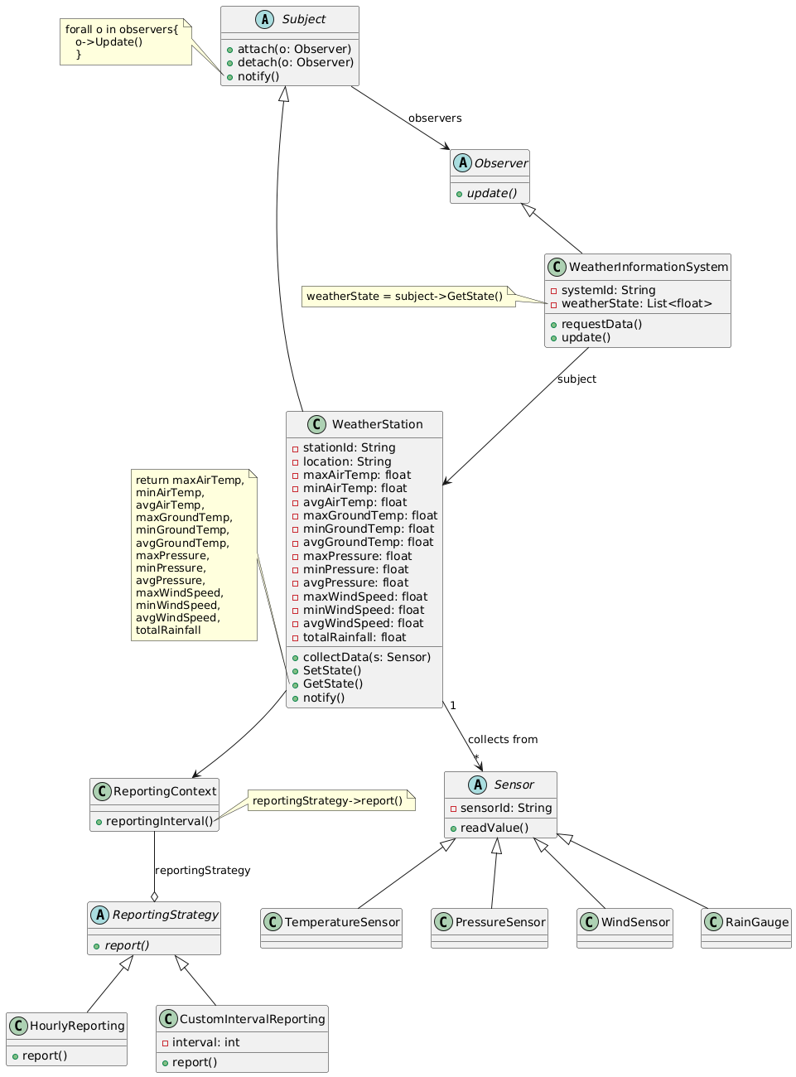
References
- Thomas, David, and Andrew Hunt. The Pragmatic Programmer: your journey to mastery. Addison-Wesley Professional, 2019.
- Gamma, E., et al. "Design patterns: elements of reusable software." Addison Welsey (1994).

